Project Report

***V.SWETHA***

# 1. Project Overview

## Project Title: 3-Tier Azure Deployment

## Project Aim:

The primary objective of this project is to design and implement a 3-tier architecture infrastructure on Microsoft Azure. The architecture separates the presentation layer (web), application logic layer, and data storage layer, enhancing scalability, security, and ease of management.

## Objectives:

* **Create three subnets in a Virtual Network (VNet): WebSubnet, AppSubnet, and DbSubnet**

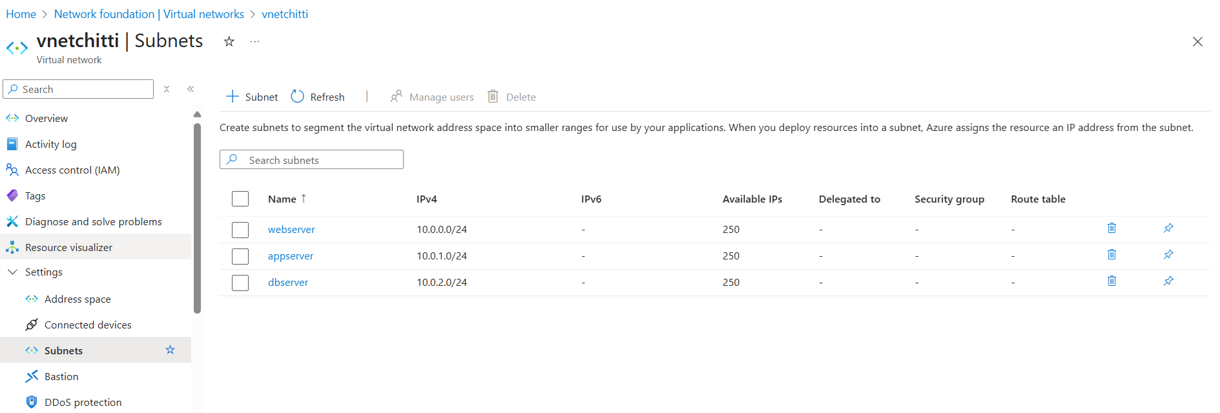

* **Deploy virtual machines in each subnet for respective roles.**

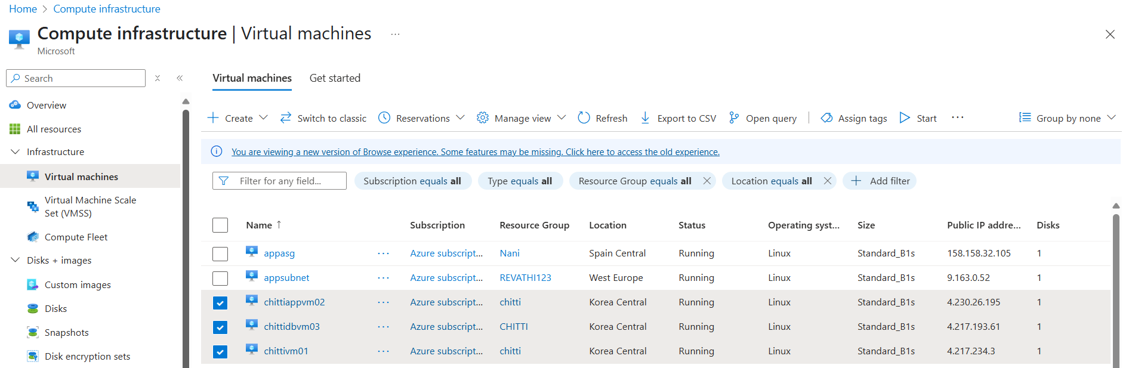

# 2. Web Tier Setup – Installing NGINX

Step-by-step installation on WEBVM01:

1. **Connect using MobaXterm via SSH.**

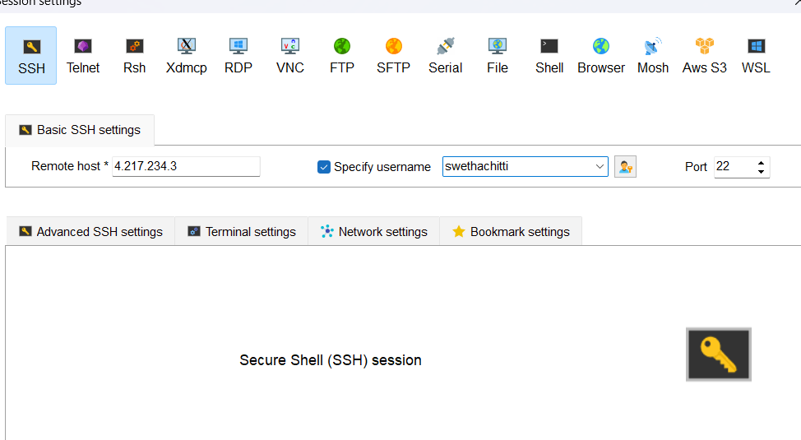

**2. Switch to root user:** • sudo su

**3. Update packages:**  
 • apt update

**4. Install NGINX**:  
 • apt install nginx -y

**5. Enable and start NGINX:** • systemctl start nginx  
 • systemctl status nginx  
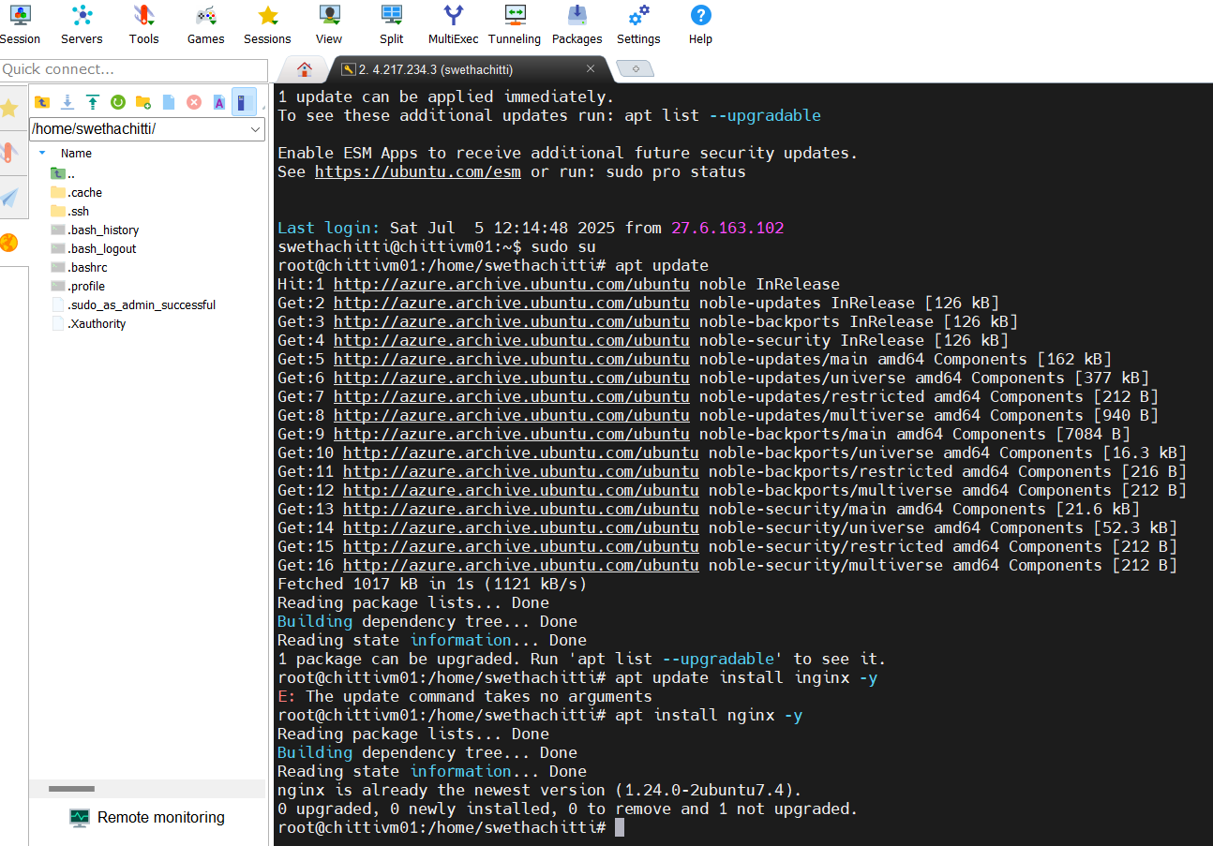

6. Allow **port 80 in NSG** settings.

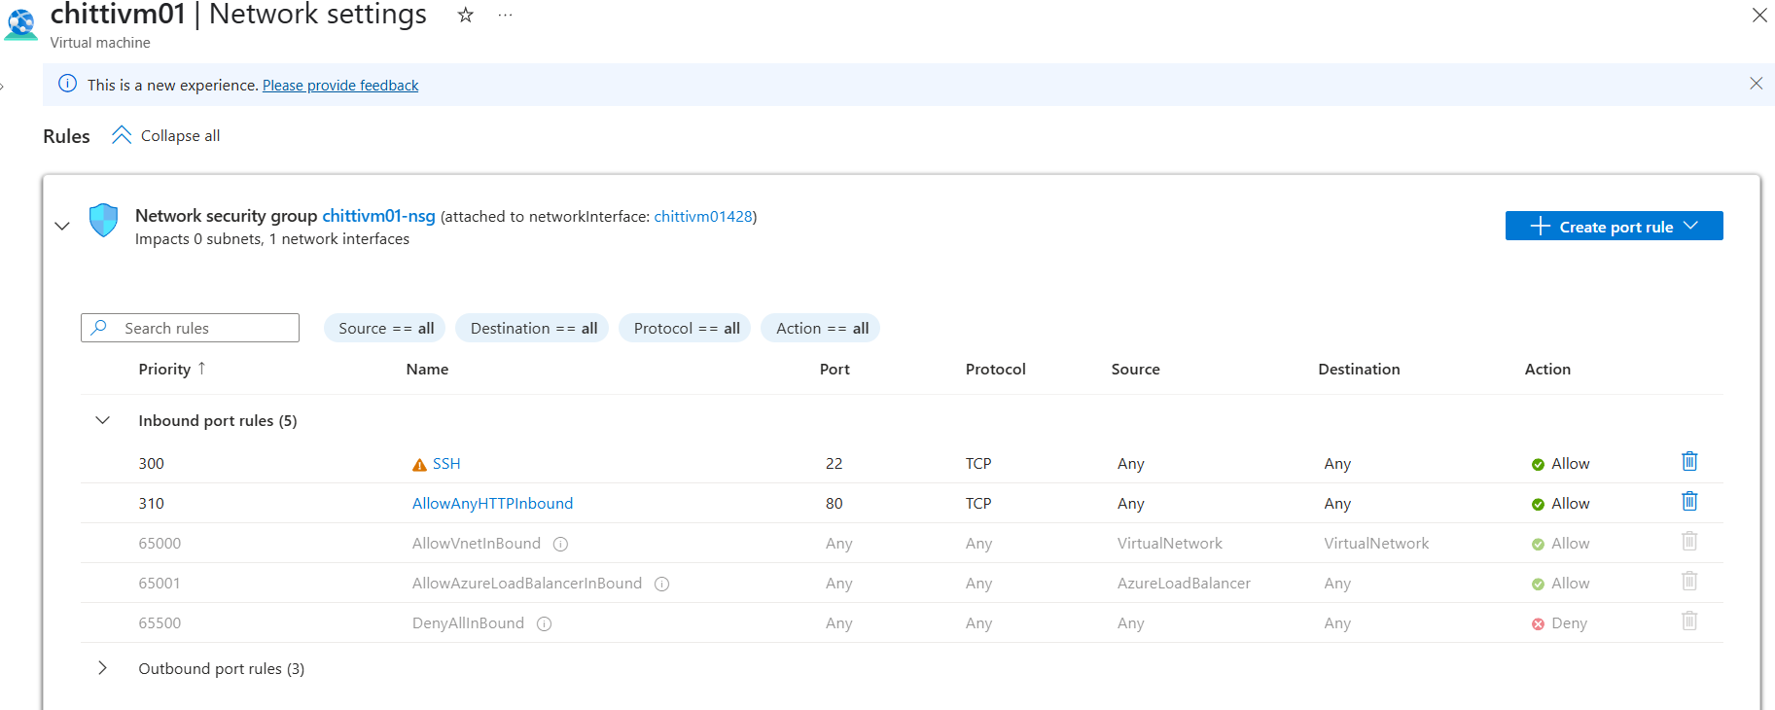

7. Access via browser: **http://<public-ip>:80**

* **http://172.172.140.88:80**

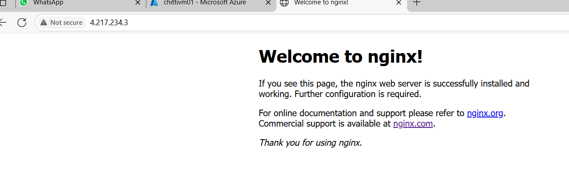

# 3. Application Tier Setup – Apache Tomcat

Steps for chittiappvm02:

1. **Connect via SSH and switch to root:**  
 • sudo su

2. **Install Java:**  
 • apt update  
 • apt install default-jdk -y

3. **Verify Java installation:** • java -version

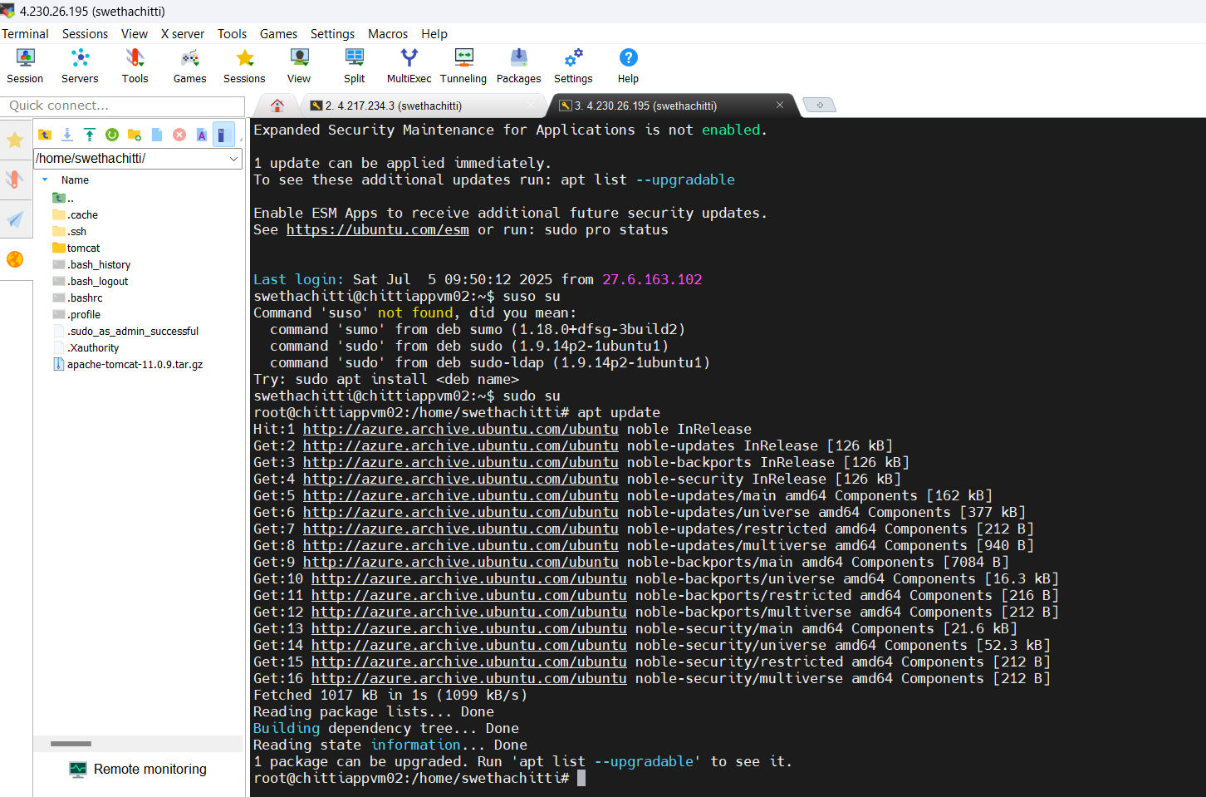

**4. Download and extract Tomcat in /opt/:**

• wget [Tomcat URL]  
 • tar -xvzf apache-tomcat.tar.gz

• mv folder to 'tomcat'

**5. Start Tomcat:** ./startup.sh

**6. Start Tomcat: ./**shutdown.sh

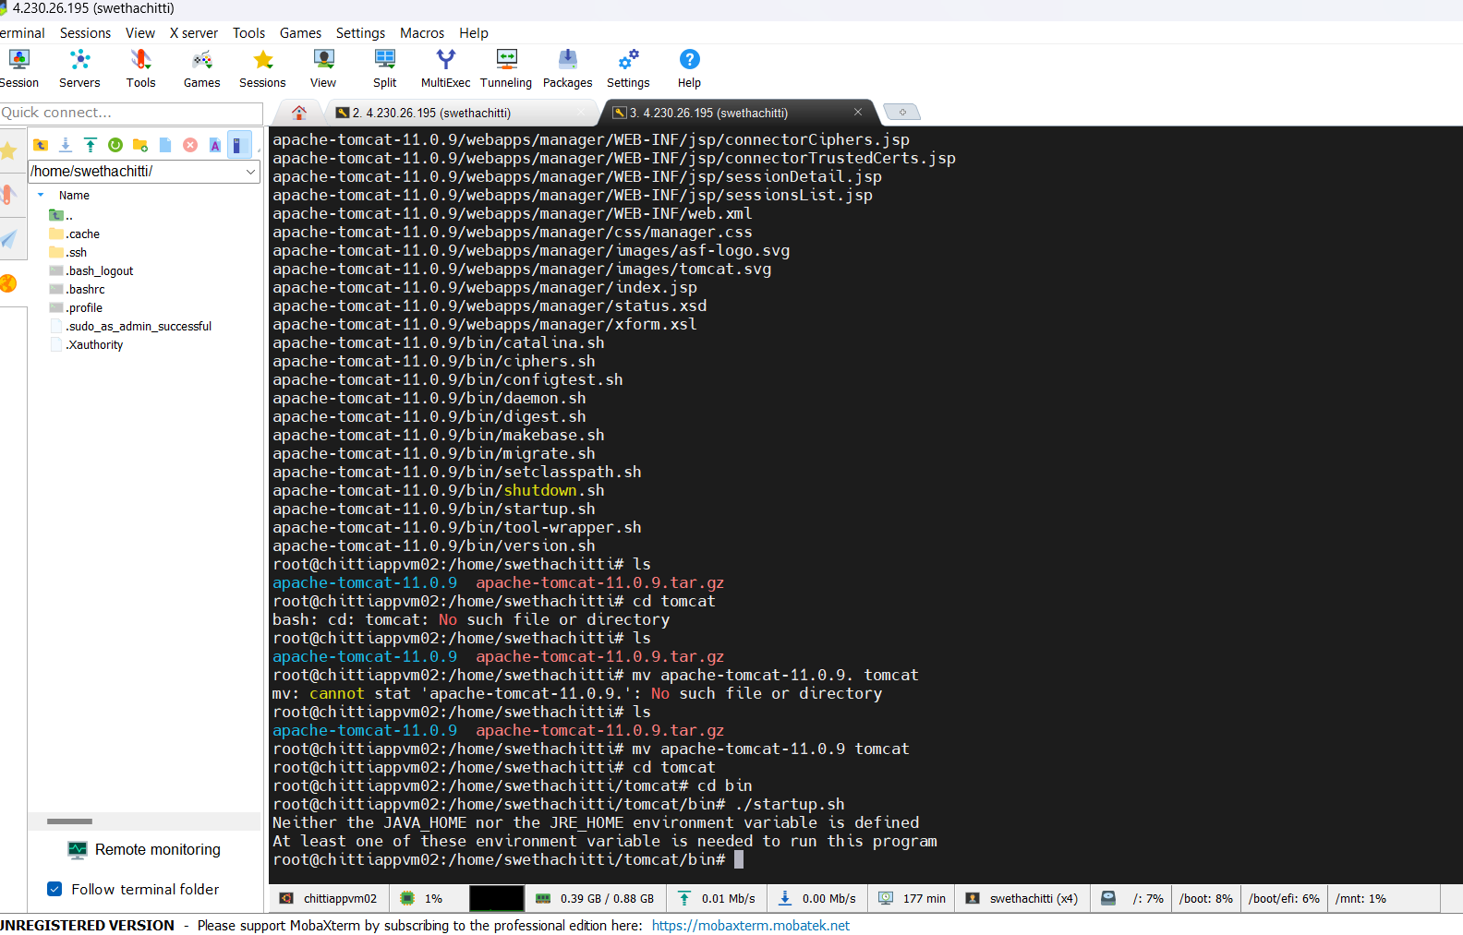

8. **Allow port 8080 in NSG.**

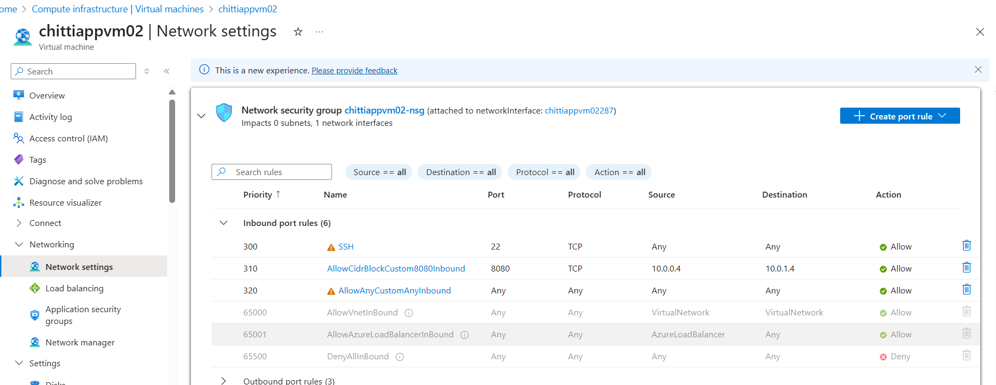

**9. Access Tomcat using**: **http://<public-ip>:8080**

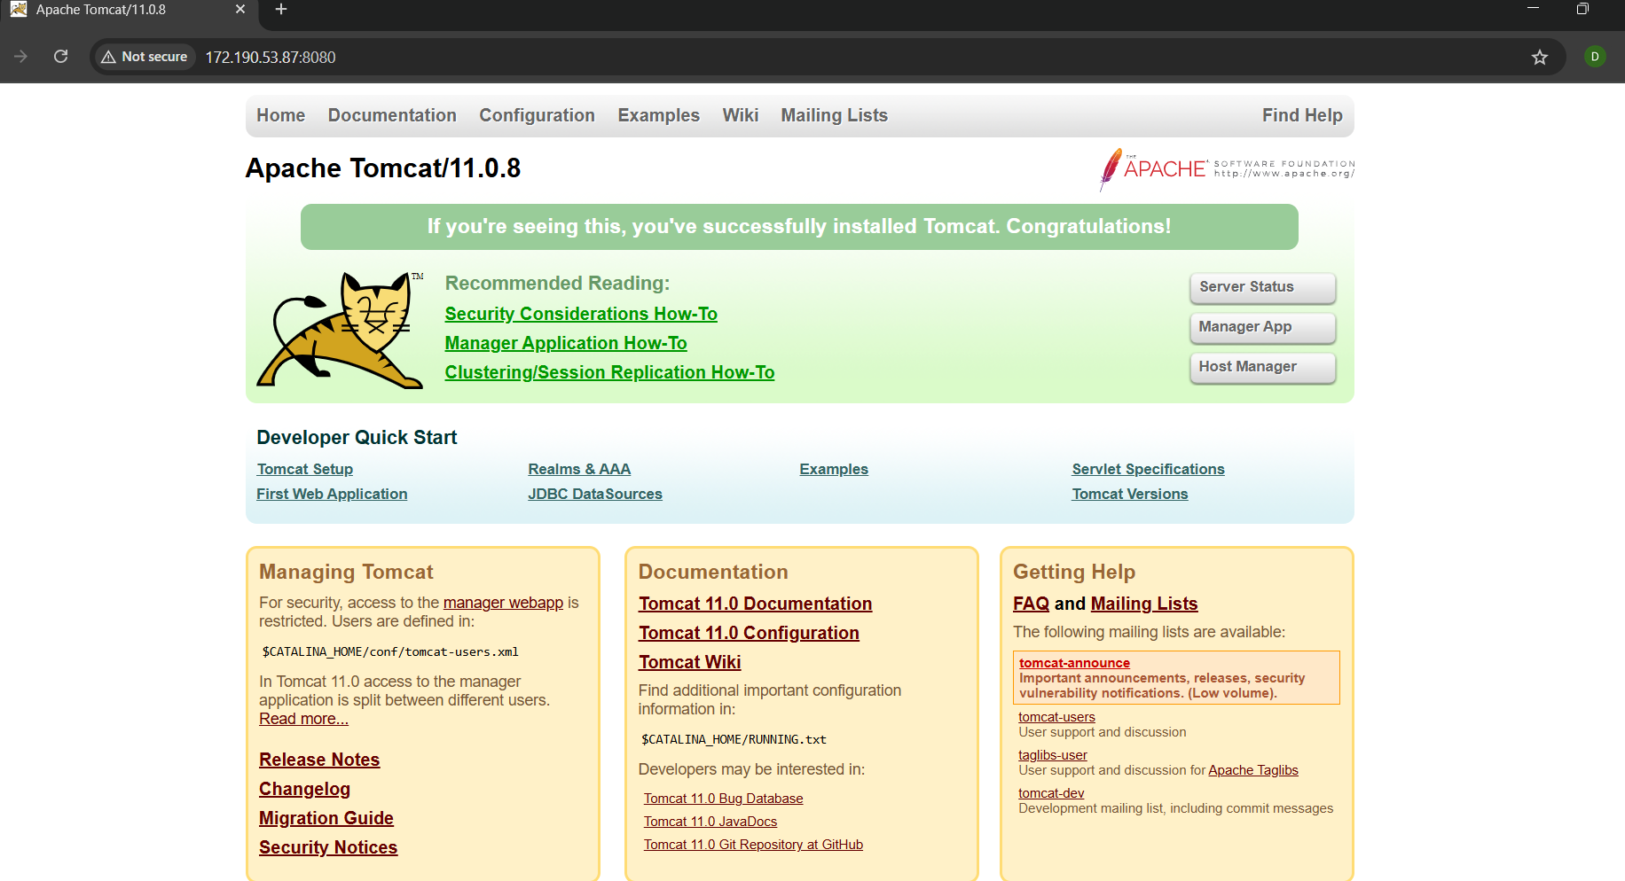

# 4. Database Tier Setup – MySQL

**Steps for chittidbvm03**:

1. **Connect via SSH and switch to root:**  
 • sudo su

2. **Update packages:**  
 • apt update

3. **Install MySQL:**  
 • apt install mysql-server -y

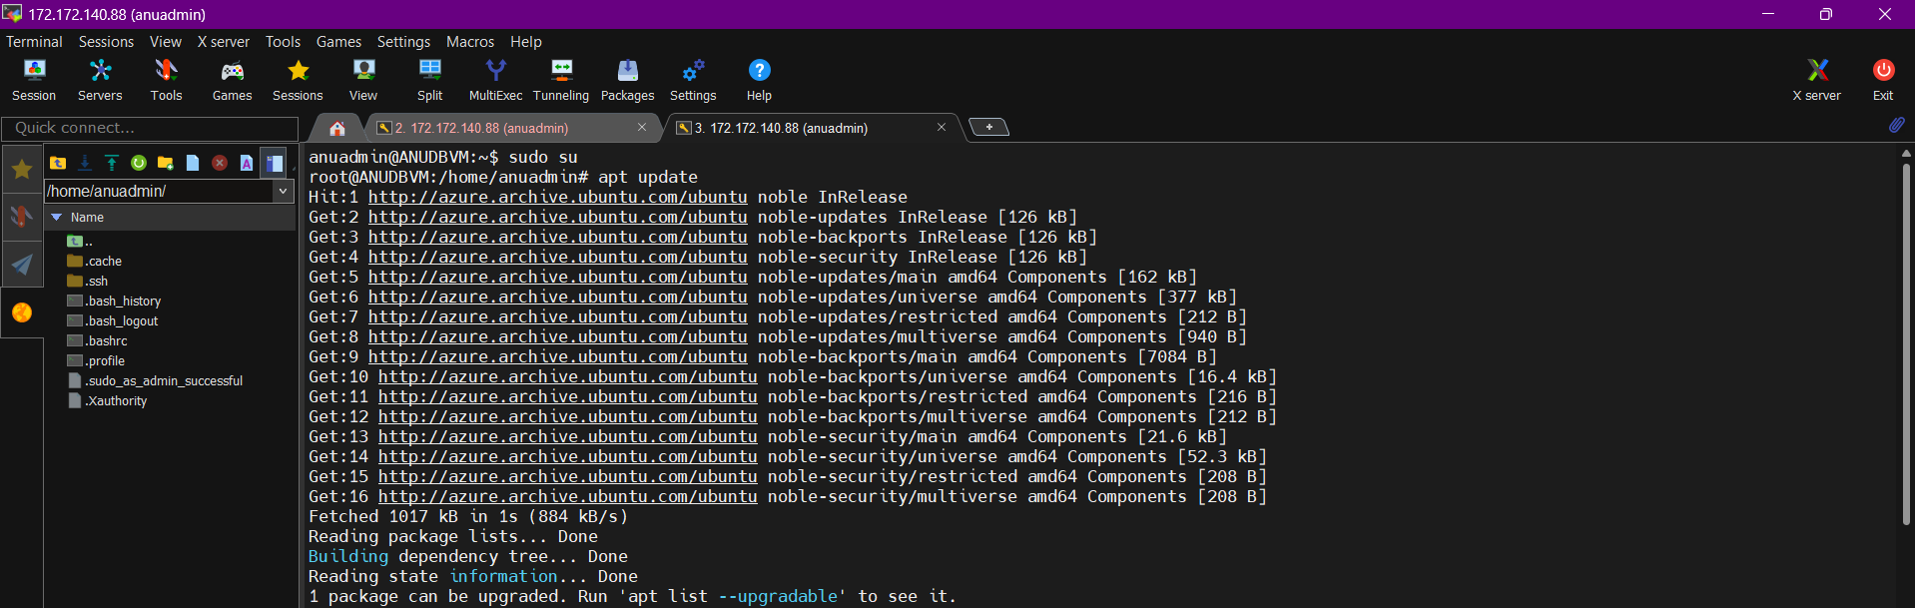

4. **Secure MySQL:**  
 • mysql_secure_installation

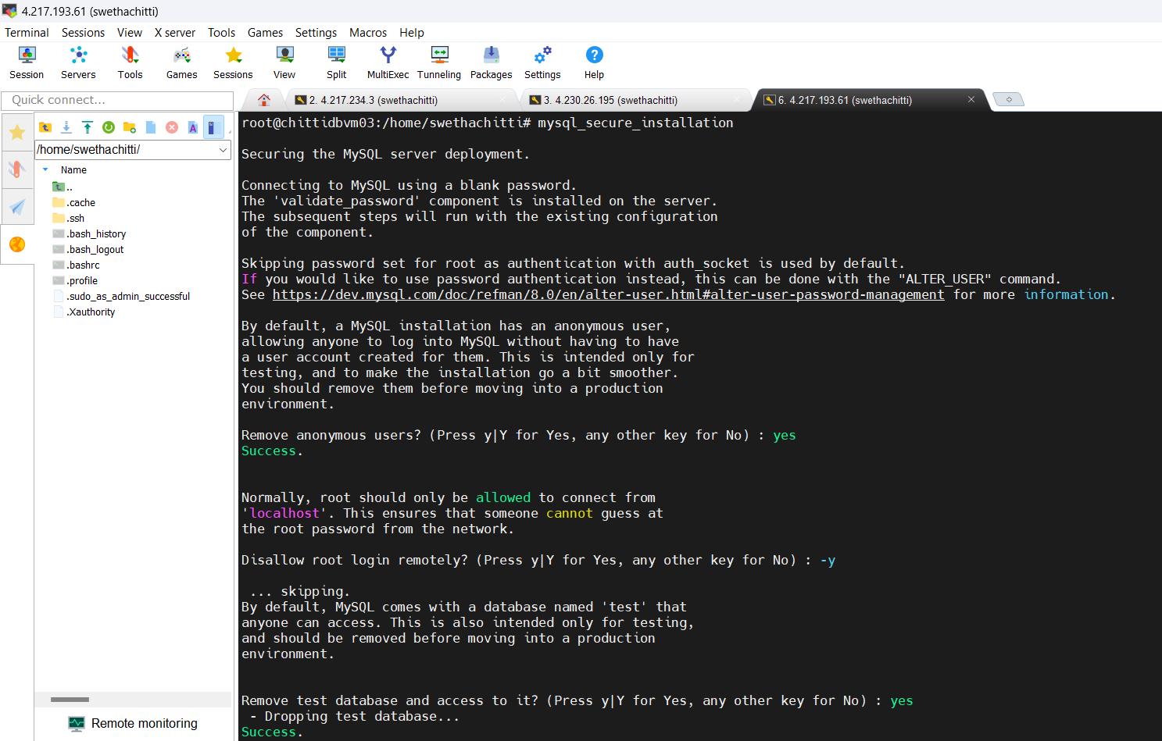

**5. Edit config file:**  
 • nano /etc/mysql/mysql.conf.d/mysqld.cnf

6. **Modify bind-address to 0.0.0.0 or specific internal IP.**

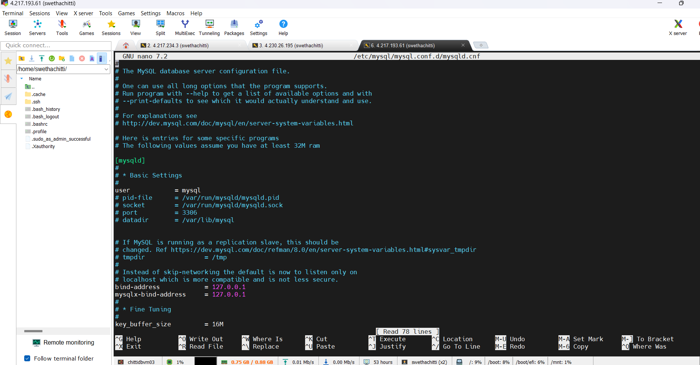

7. **Restart MySQL:**  
 • systemctl restart mysql

8. **Check MySQL status:**  
 • systemctl status mysql

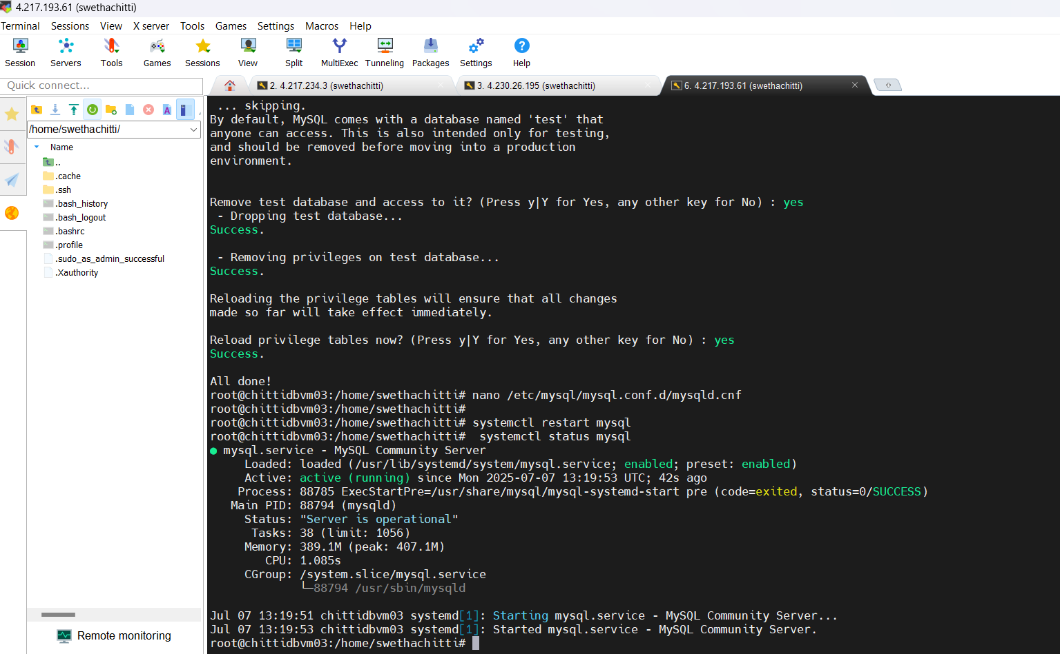

# 5. Network Security Groups (NSG) Configuration

Each tier is protected by NSG rules to control traffic securely between layers.

• **swethaWEBVM**:  
 - Allow HTTP/HTTPS (ports 80, 443)  
 - Allow SSH(port 22)



**• swethaVMAPP(NSG):**  
 - Allow from chittiAPPvm02 on port 8080



**• chittidbvm03:**  
 - Allow only from chittidbvm03 on port 3306  
 - Deny all other inbound connections

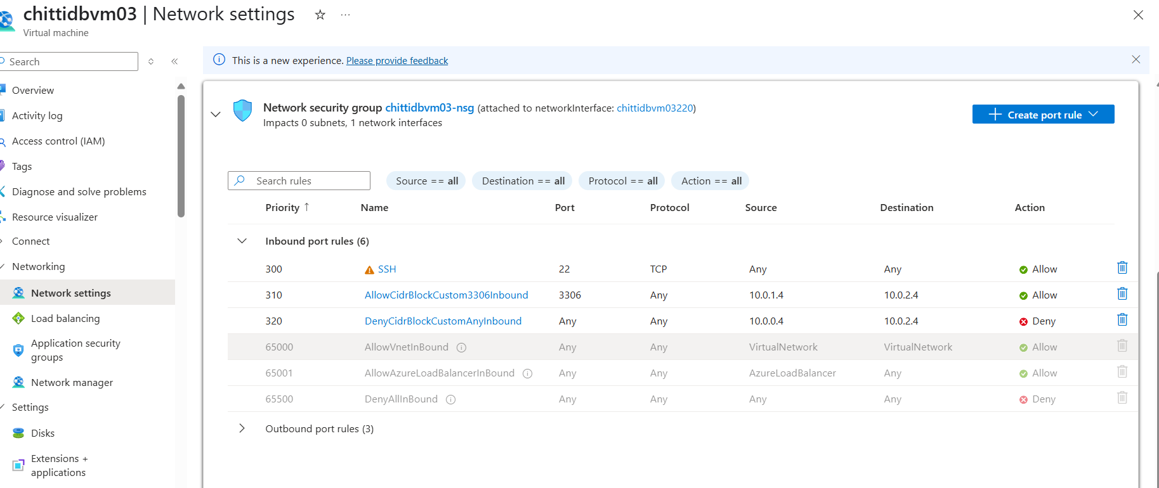

This ensures layered security and isolation.

**Connection status:**

* Checking Connection status from chittiappvm02 to chittidbvm03 (telnet<ipaddress>portnumber)

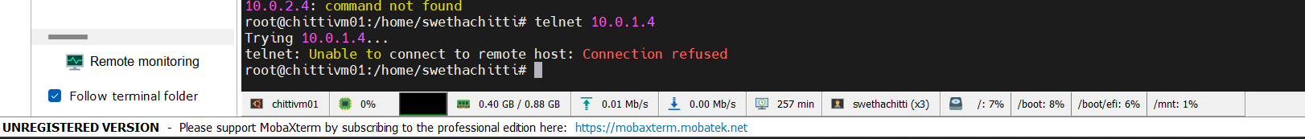

* Checking Connection status from chittiVMWEB TO chittiVMDB 03(telnet<ipaddress>portnumber)



# Conclusion:

The implementation of a 3-tier architecture in Azure improves security, scalability, and maintainability. By isolating each layer with dedicated VMs and NSG rules, the infrastructure supports modern application needs securely. Using MobaXterm, Linux commands, and service configuration, each component was successfully deployed and tested.